Things I want to add to the website
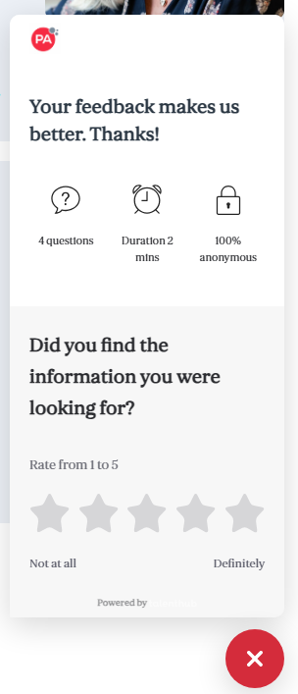
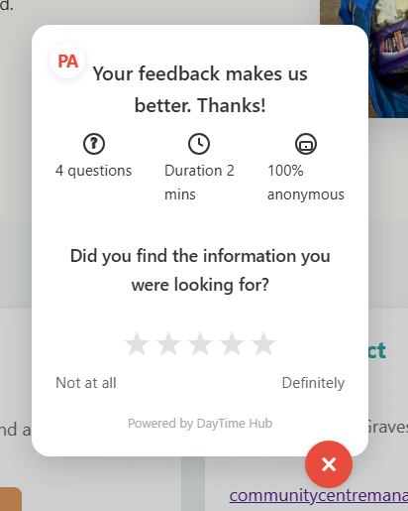
Good. Now, can you make sure that the PA logo changes to DTH (meaning they time up) can you make sure it doesn't cover the back-to-top button? Make sure it's above it a little bit. How can you make sure the X is blue, not red? And the dTH logo text is Blue as well. I can make sure the pop-up still allows users to scroll. Stay is in a static position. But still allows them to scroll.
